Competitive Shooters of Lake Norman USPSA March 26th, 2026
COURSE DESIGNER: Ike Starnes
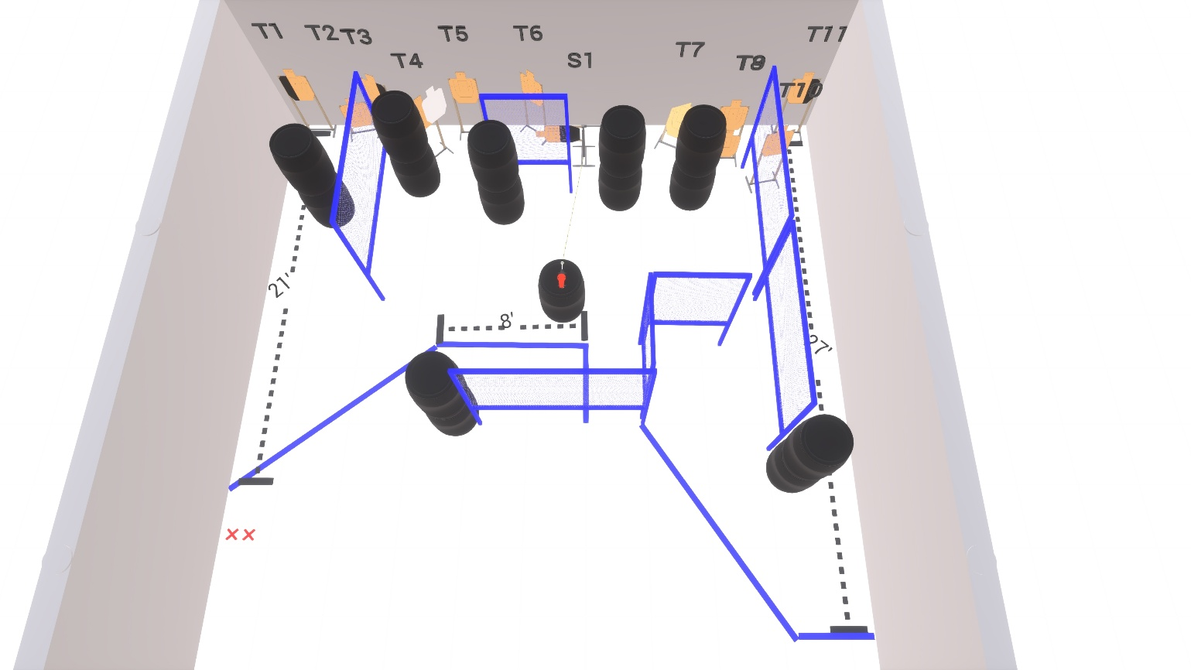

Stage 4 – Pretend this swinger is a Holy Monkey
26 rounds, 130 points, Comstock
There are 12 cardboard targets with some no-shoots.
The best 2 hits per static cardboard will be scored.
The best 4 hits on the swinger will be scored.
Starting with both feet on the Xs.
Handgun is loaded and holstered, wrists below belt.
PCC is loaded held in both hands, stock touching belt.
On the audible start signal, engage targets from within the shooting area.

